CS-1 (2016-2019) Programming Board Questions

Q.1) WAP in C++ to print first 20 terms of Fibonacci Series (Series is 0,1,1,2,3,5,8….)

Q.2) Implement a class temperature. Include a constructor in it which accepts value of temperature from user in degree Celsius. Include two Fn in it, one of which calculates its equivalent temperature in degree Fahrenheit and other functions prints the answer:

$$\frac{C}{5}=\frac{F-32}{9}$$

­­

Q.3) Implement a class avg. Include a constructor in it which will accept value of three variables from user. Include two more functions in it, one function calculates average and other prints it.

Q.4)



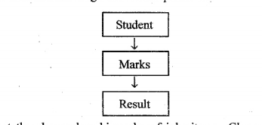

Implement the above class hierarchy of inheritance. Class student accepts roll no. of student, class marks accepts marks of three subjects and class result calculates the total and print all details. (Create obj of class result).

Q.5)

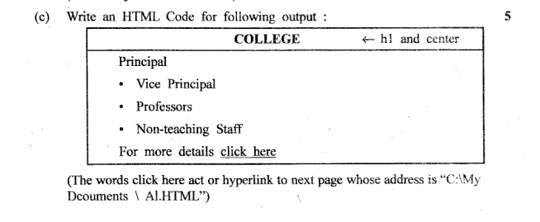

Q.6)

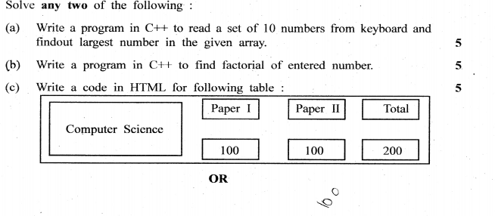

Q.7)

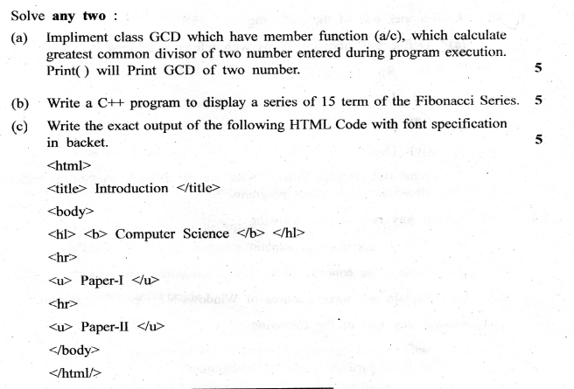

Q.8)

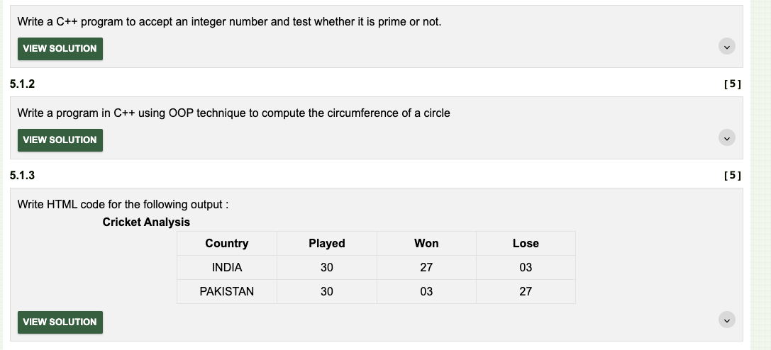

Q.9)

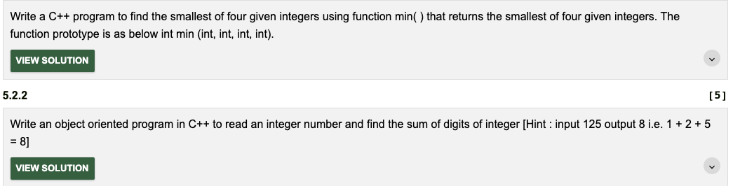



Q.10)

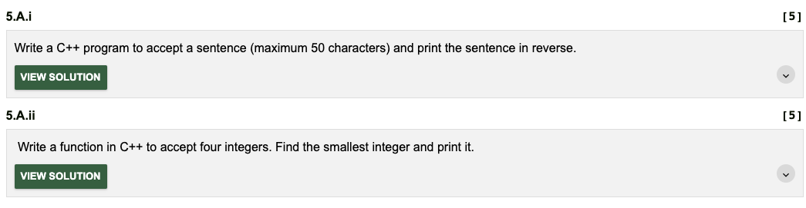

Q.11)

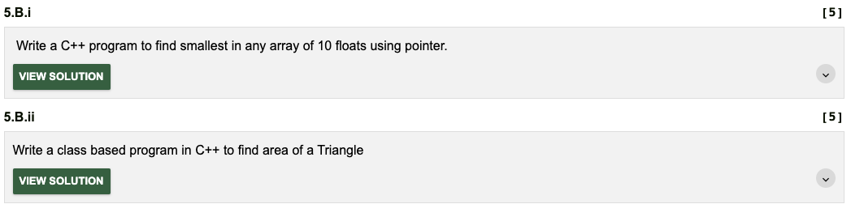

Q.12)

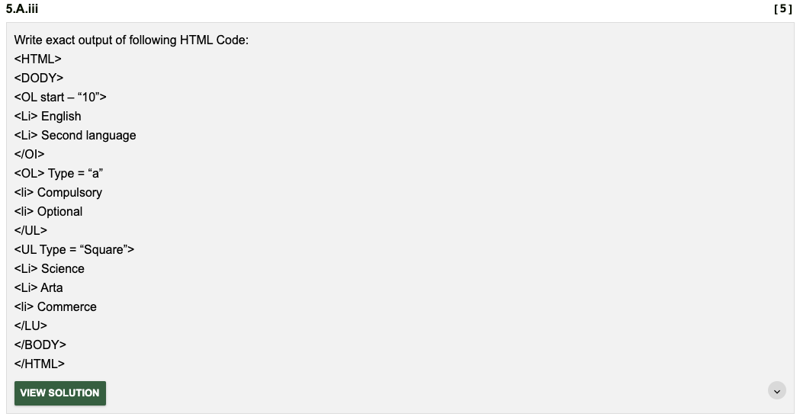

Q) WAP that takes input of 10 numbers in an array and stores them. Print the sum and average of the array elements.

Q)WAP to demonstrate the example of Single Inheritance.



Q) WAP to demonstrate the example of Multilevel Inheritance



Q) WAP to read data variables day, month, and year of a class date by member function and displays the contents of class object.



Q)Explain Memory Allocation for Objects.



Q) Explain Objects as Function Arguments; Pass by value and Pass By Reference.



Q)WAP to overload binary + operator for addition of complex numbers

Q)WAP for overloading unary + operator.

Q) Write a program which implements data conversion from one class to another.

Q) Write a program in C++ that first initializes an array of given 10 real numbers. The program must sort numbers in ascending/descending order using **Bubble – Sort**method. It should print the given list of numbers as well as the sorted list

Q)Write a program in C++ that first initializes an array of five given numbers (short /float/ double). The program must add these numbers by traversing this array with a pointer. The output should print the starting address of the array with the size of the number (in bytes) to which it points. The program must also print the sum and pointer address with addition of every number as well as the ending address.